Learning Journal

13/10/2020

I started looking into the movement that I would need for both the tutorial and the 3d level design. The movement that I was looking for was for the player to turn on an axis. I did not need to investigate jumping because it isn’t required for the game I am designing.

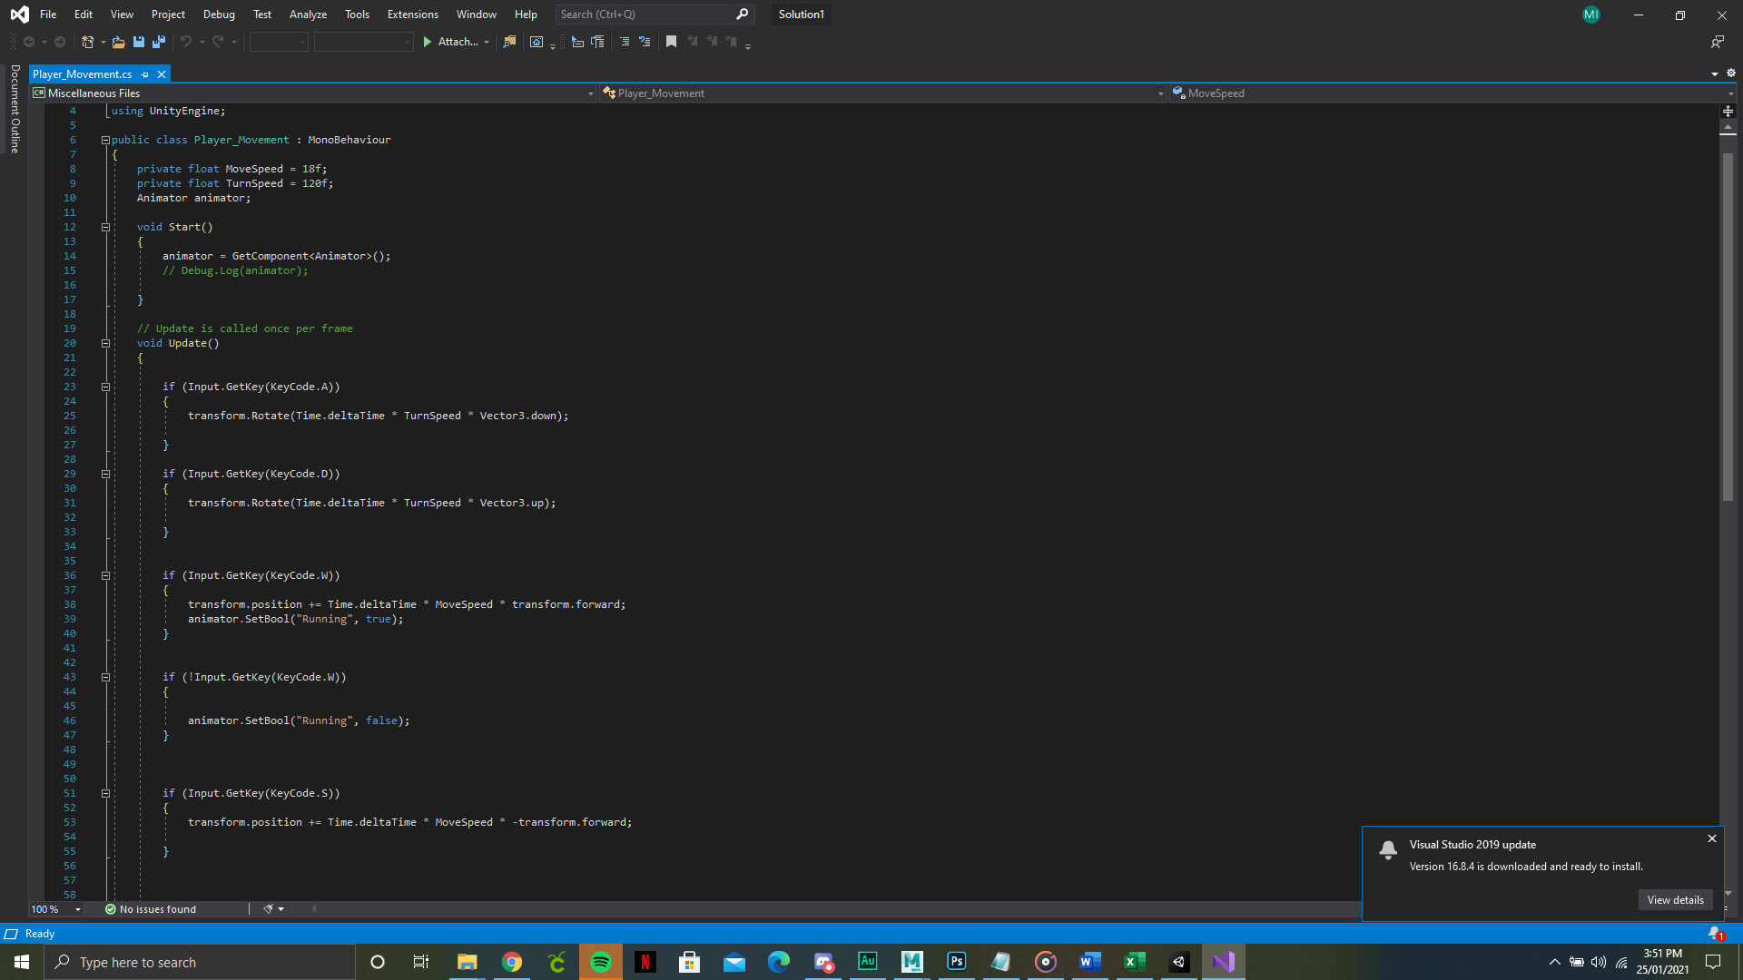

17/10/2020

I had been looking at ways to create a way to have the camera track the player. I wrote a script in order to do so, the script worked but it wasn’t smooth enough and it didn’t work the way I had wanted it to. I then investigated Cinemachine, it allowed me to make the camera run a much smoother and it solved the issue that I had run into. Cinemachine allows the player to stay in the frame and stay at the distance that I have set up.

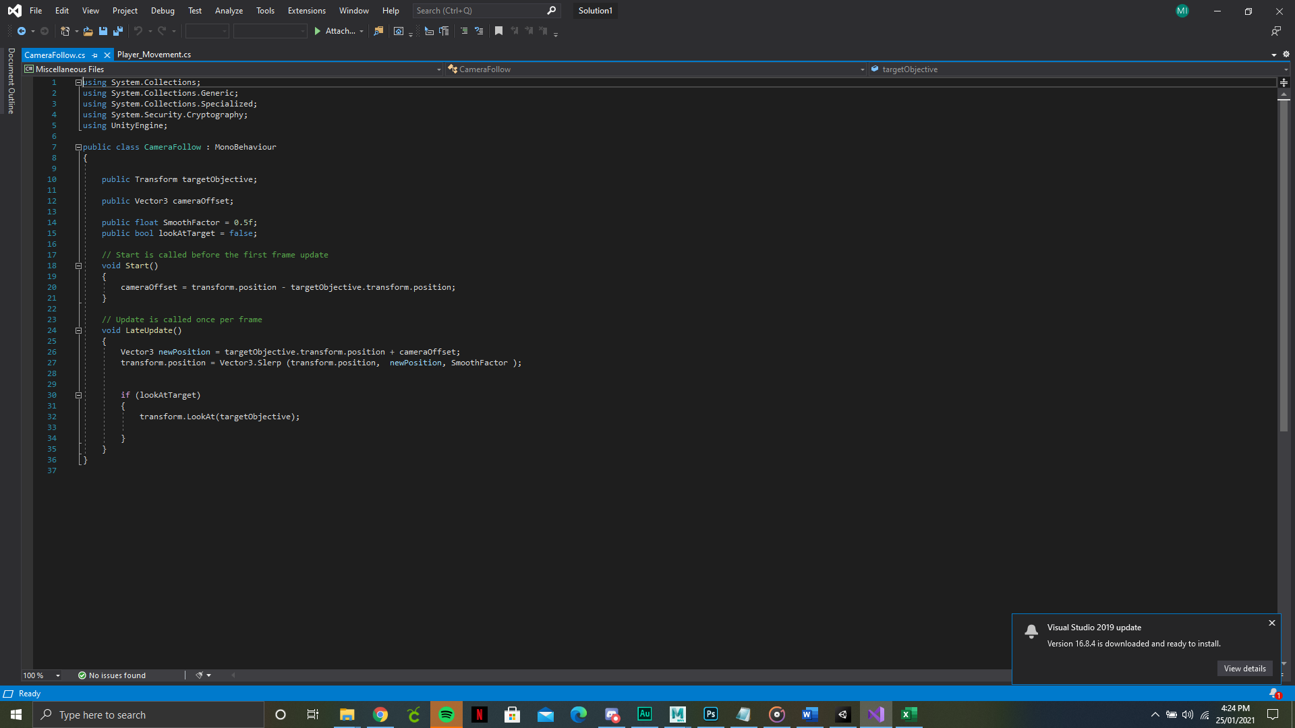

20/10/2020

I needed to research patrolling because I wanted to have other shoppers running around the store acting as a distraction/obstacle. The patrolling is done by using arrays and using waypoints in order to give the AI a path for them to follow.

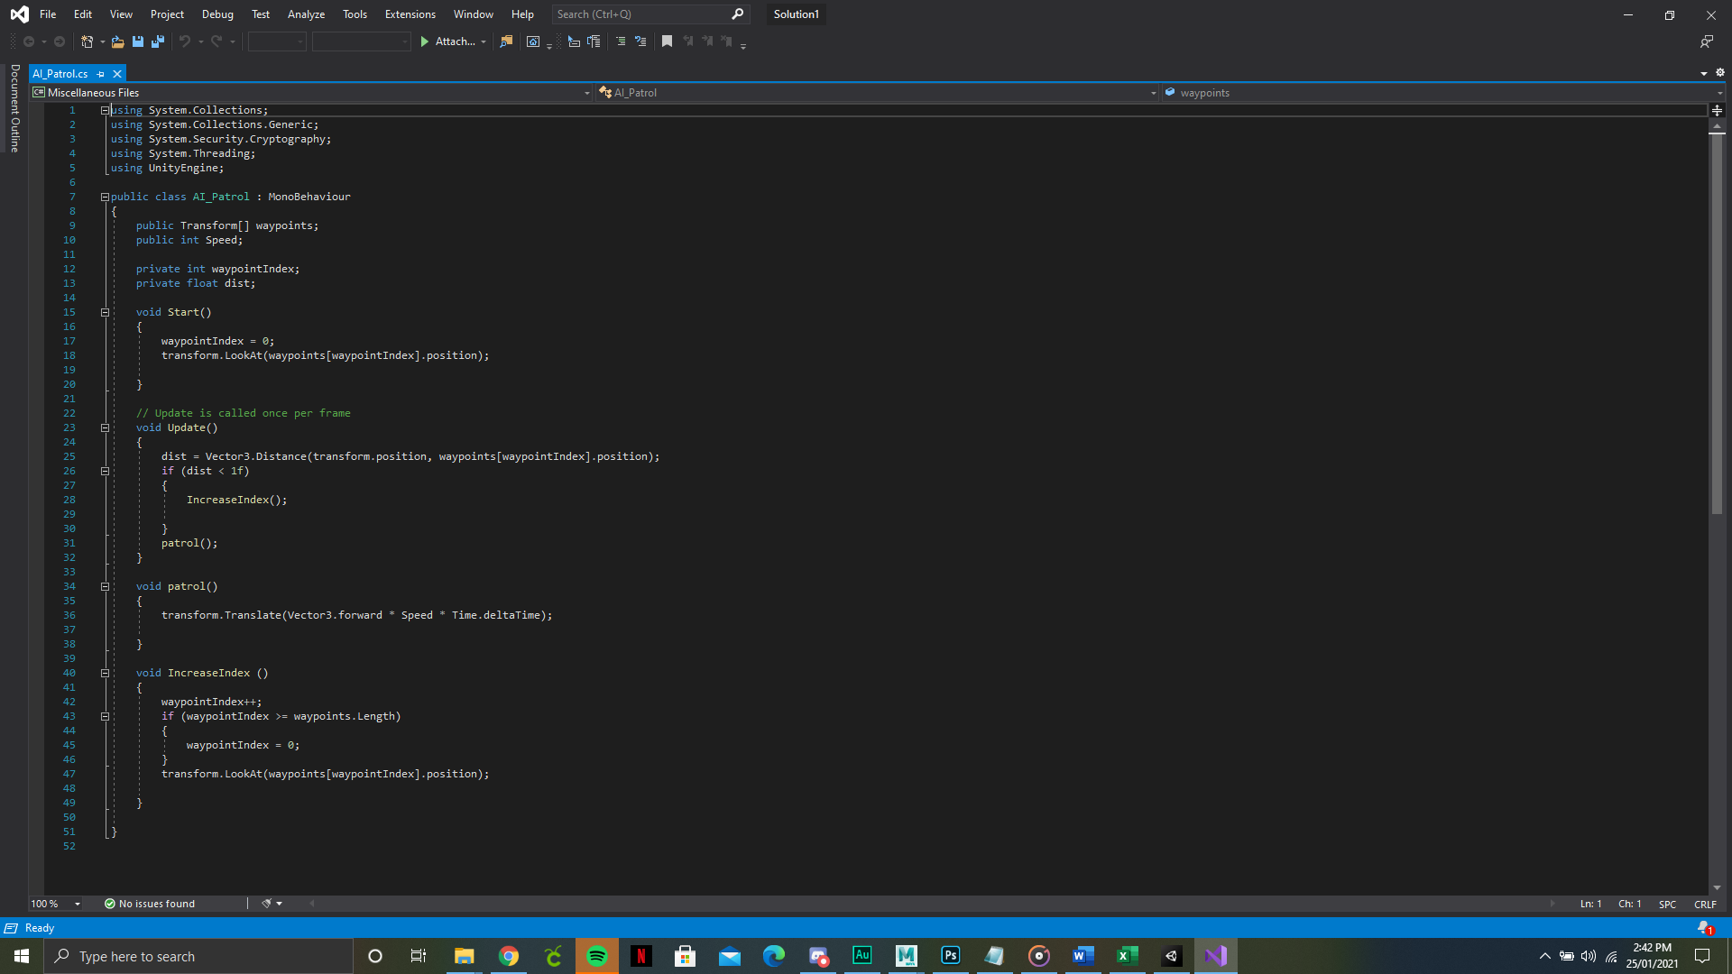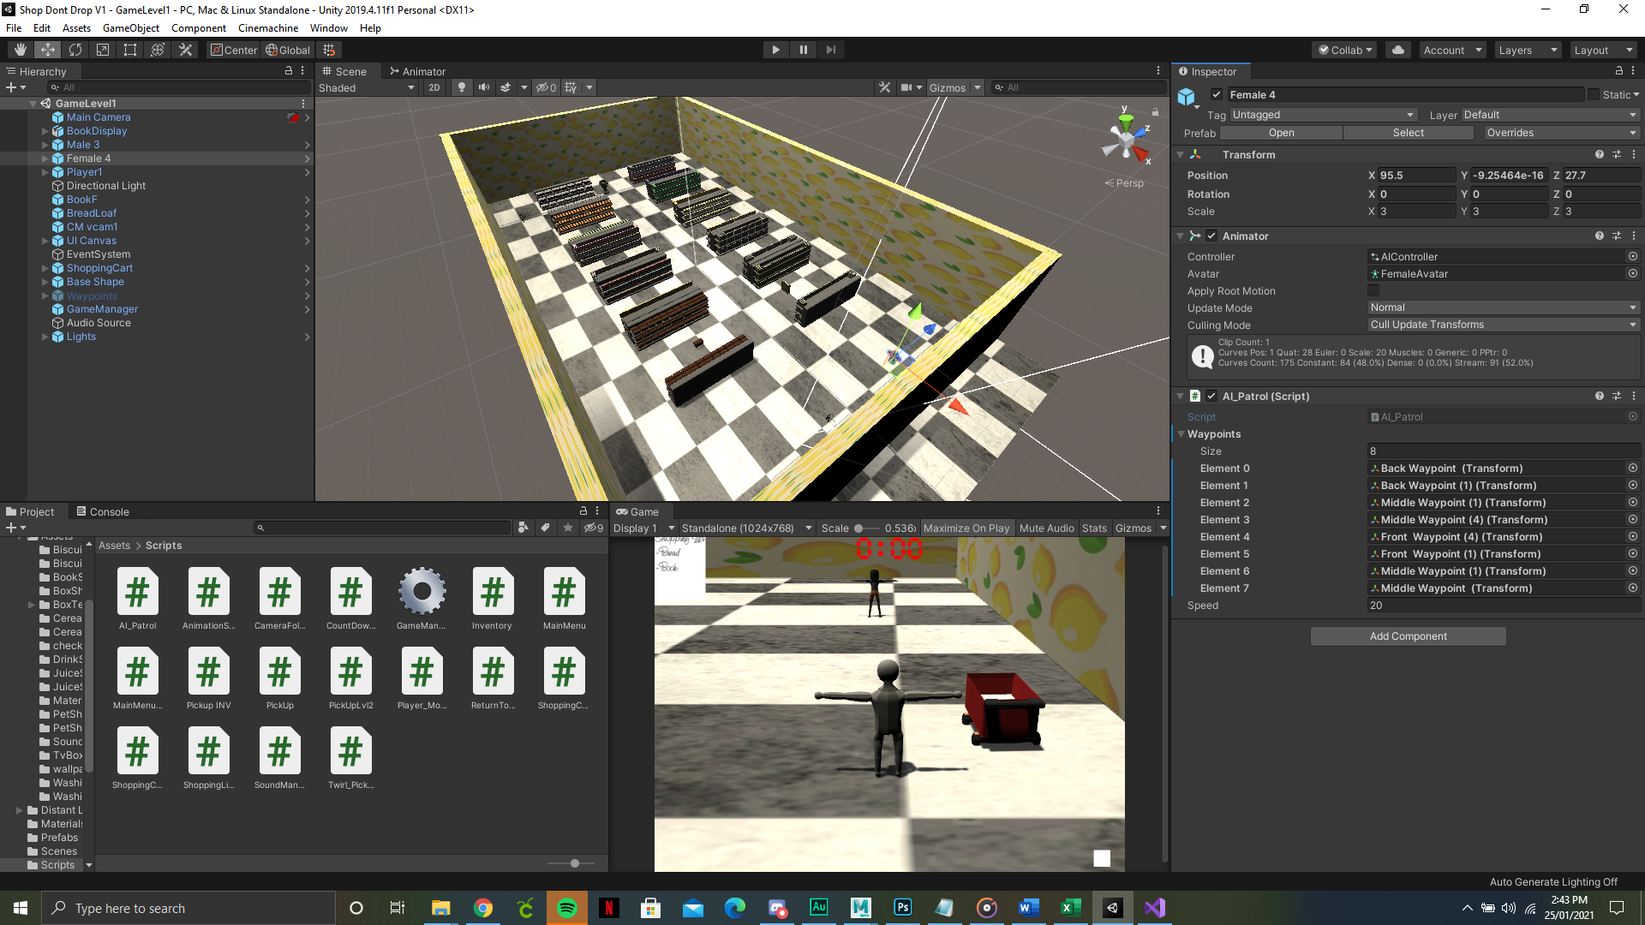

27/10/2020

I spent a lot of time looking into making a level restart button because the one I had attempted to create didn’t work. I found a quicker way that I found easier even though it was technically less efficient than the previous one that would not work for me. The down side to this way of approaching it like this is due to how there is a little more code then is necessary.

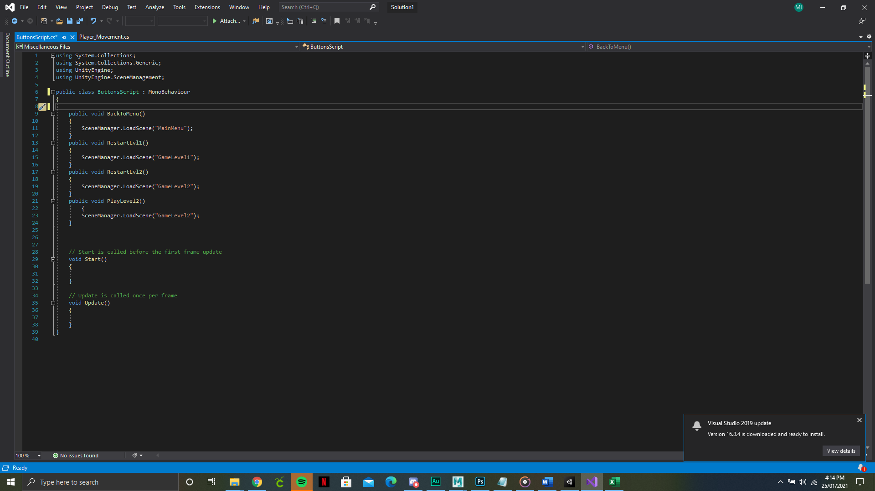

13/11/2020 And 14/11/2020

One of the most trivial tasks that I ran into was the creation of one of my core mechanics. The mechanic is to store the items that are picked up then display the photo of the item that has been collected. The collection method was something I was struggling with for a long period; however, I was able to get some assistance from David and together we were able to build an inventory system which was accustom to the game I am creating. The scripts below include the various aspects that link in to make the whole inventory system work. This includes the code for the pickup items, the shopping cart (Where the items would be deposited), the shopping list (this is where the UI elements of the game were stored) and the Inventory (where the script would hold the item)

